



simlab.co.kr/AllegroHand/wiki

**Allegro Hand User's Manual**

Copyright © 2008-2013 SimLab Co., Ltd.

Hyobong8 Bldg 2nd Fl, 1425-9 Seocho-Dong, Seocho-Gu,

Seoul 137-864, Korea

# Copyright & Trademark Notice

Allegro, the Allegro logo and all related files and documentation are Copyright © 2008-2013 by SimLab Co., Ltd. All rights reserved.

Allegro, Allegro Hand, Allegro Application Studio for Allegro Hand, Allegro Hand Application Studio, and RoboticsLab are trademarks of SimLab Co., Ltd. All other trademarks or registered trademarks mentioned are the property of their respective owners.

Contents

Copyright & Trademark Notice i

Quick Start Guide 1

In The Box 1

Power Supply 1

Read these Sections First 1

Allegro Hand Overview 2

Features 2

Technical Specifications 3

System Requirements 4

Products 4

Installing Allegro Hand Application Studio (AHAS) 5

AHAS Installation 5

VC++ Redistributable 10

USB License Dongle Driver 10

Finishing Installation 11

AHAS License Registration 11

CAN Driver Installation 12

NI USB-8473s CAN 12

Softing CAN-AC2-PCI 12

Kvaser PCIcan 4xHS 12

ESD CAN-PCI/266 12

Using Allegro Hand Application Studio (AHAS) 13

Running AHAS 13

Which Hand? 13

Virtual 13

Actual 13

Virtual Hand Simulation 14

Home 15

Ready 15

Grasp 3 15

Grasp 4 15

Pinching (I) 15

Pinching (M) 15

Envelop 15

Test Encoders (actual hand only) 15

Test Motors (actual hand only) 15

Sliders 16

Actual Hand 17

Wiring 17

Power 17

AHAS 18

Quitting 18

Joint Dimensions 19

Joint Directions 20

Right Hand 20

Left Hand 20

Mounting the Allegro Hand 21

Mounting Block Removal 21

Mounting 23

Reassembly 23

Mount Block Dimensions 24

CAN Protocol 25

Baud-Rate 25

Non-Periodic Communication 25

Periodic Communication 25

CAN Frames 25

Standard CAN Packet 25

ID (Message Identifier) 26

Command Identifiers 26

Source and Destination Identifiers 26

Case-study: Softing CAN 27

Opening the CAN Communication Channel 27

CAN Initialization 28

Starting Periodic CAN Communication 28

Stopping Periodic CAN Communication 28

Transmitting Control Torques 29

Receiving Joint Angles 30

Technical Support 31

# Quick Start Guide

## In The Box

Included are the software and hardware necessary to get you started.

1. Allegro Hand
2. Allegro Hand Application Studio
   1. Installation CD
   2. USB License Dongle
3. 2mm Hex Wrench
4. M2x5mm socket-head cap screws (extra) qty 2
5. Wires/Connectors
   1. 4-pin wired male connector (power/CAN) qty 1

***Note:*** *Only hand end of wire is terminated.*

*CAN interface end must be terminated by user.*

* 1. 4-pin male connector body qty 1
  2. Wire terminals (for use with connector) qty 4

## Power Supply

Power provided to the Allegro Hand must meet the following specifications:

*A power supply meeting these requirements can be purchased along with the Allegro Hand*

Voltage: 7.4VDC (7.0V - 8.1V)

Amperage: 5A (minimum)

## 

## Read these Sections First

1. Installing Allegro Hand Application Studio (AHAS)
2. Using Allegro Hand Application Studio

## Wiki for Users

All information provided in this user's manual along with a forum and tutorials is available at

**simlab.co.kr/AllegroHand/wiki**

## Allegro Hand Hard Case

Optionally, a hard-plastic protective case can be purchased from SimLab for storing and transporting your Allegro Hand. Please ask for details.

***Note:*** *The names Allegro Application Studio for Allegro Hand and Allegro Hand Application Studio both refer to the software included with the Allegro Hand*

# Allegro Hand Overview

## http://simlab.dyndns.org:9000/AllegroHandWiki/images/f/f0/AH_4pics.jpg

**Allegro Hand is a low-cost and highly adaptive robotic hand.**

With four fingers and sixteen independent current-controlled joints,  
it's the perfect platform for grasp and manipulation research.

## Features

* Lightweight and portable anthropomorphic design
* Low-cost dexterous manipulation with applications in research and industry
* Multiple ready-to-use sensorless grasping algorithms capable of handling a variety of object geometries
* Capable of holding up to 1.5kg
* 16 independent current-controlled joints (4 fingers x 4 DOF ea.)
* Allegro Hand Application Studio integration allows for simulation based algorithm prototyping without ever changing your code
* Support for real-time control and online simulation

# Technical Specifications

|  |  |  |
| --- | --- | --- |
| ***Number of Fingers*** | *Three (3) fingers and a thumb (1) = 4* | |
| ***Degrees of Freedom*** | *4 fingers x 4 = 16 (Active)* | |
| ***Actuation*** | *Type* | *DC Motor* |
| *Gear Ratio* | *1:369* |
| *Max. Torque* | *0.70 (Nm)* |
| *Overdrive Torque* | *0.90 (kg)* |
| ***Weight*** | *Finger* | *0.17 (kg)* |
| *Thumb* | *0.19 (kg)* |
| *Total* | *1.20 (kg)* |
| ***Joint Resolution*** | *Measurement* | *Potentiometer* |
| *Resolution (nominal)* | *0.002 (deg)* |
| ***Communication*** | *Type* | *CAN* |
| *Frequency* | *333 (Hz)* |
| ***Power Requirement*** | *7.4VDC (7.0V - 8.1V), 5A Minimum* | |

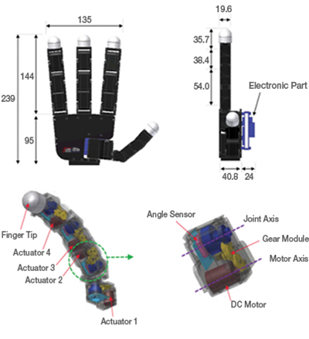

# System Requirements

|  |  |
| --- | --- |
| CPU | Intel® Core™2 Duo or higher |
| **RAM** | at least 2GB |
| **HDD** | at least 2GB |
| **Graphics** | OpenGL 3.0 H/W Acceleration enabled with at least 64Mb of video RAM |
| **OS** | MS Windows® XP, |
| MS Windows® Vista,0.19 |
| MS Windows® 7 |
| **Additional S/W** | MS Visual Studio® |
| **Communication** | NI, Softing, Kvaser or ESD CAN ***Note:****Any CAN interface can be user-configured for use with the Allegro Hand.* |

# Products

AllegroLogo.jpg

The Allegro Hand comes with its own version of SimLab's Allegro Application Studio (AAS), a robotics software for developing and testing control algorithms for a variety of commercial robots. AAS for the Allegro Hand includes a customized kinematics/dynamics simulator based on RoboticsLab. Algorithms developed can be applied to the virtual hand as well as directly to the real hand without any changes to the code.

For more information, please visit our Allegro Application Studio website:

**www.simlab.co.kr/Allegro-Application-Studio.htm**

RoboticsLabLogo.jpg

Paired with our RoboticsLab development environment, the user can take full advantage of robust dynamics and system control engines as well as out feature-rich controls SDK. RoboticsLab also enables users to easily model custom robots and test environments in 3D and add built-in and custom sensors, actuators and other devices. RoboticsLab provides the flexibility necessary to prototype and test control algorithms for any system.

For more information, please visit our RoboticsLab website:

**www.simlab.co.kr/RoboticsLab.htm**

# Installing Allegro Hand Application Studio (AHAS)

Allegro Hand Application Studio (AHAS) for the Allegro Hand comes as a packaged installer (CD ROM included) for easy installation. This setup tutorial will guide you through the steps necessary to get your Allegro Hand up and running for the first time.

Insert the CD into your Windows computer to install AHAS. If the installer does not start automatically, please navigate to the installer CD to locate the AHAS setup program.

*Start Menu > Computer > CD/DVD Drive > setup_AllegroHand.exe*

## AHAS Installation

Upon beginning the installer, you will be greeted with the Allegro Hand Application Studio (AHAS) welcome screen. At this point, if you have any other programs running, please exit the AHAS installer, close all other programs, then restart the installation process. Click *Next* when you are ready to continue.

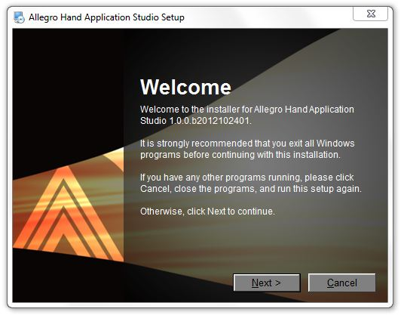

Please fully read the RoboticsLab/Allegro Hand Application Studio License Agreement then, if you agree, select that option and click *Next*.

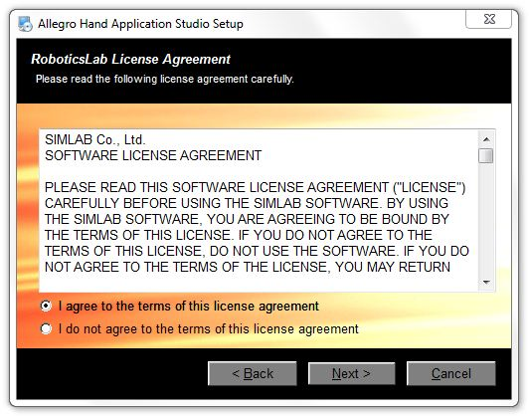

On the next page, you will be prompted to enter the names of yourself and your organization. Please do so then click *Next*.

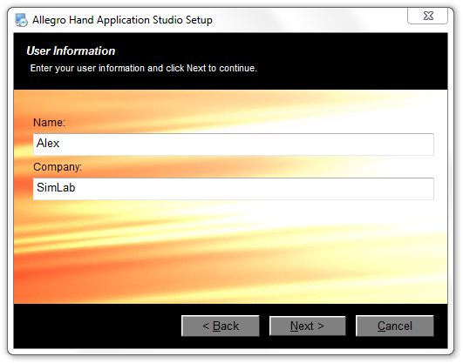

Next, you will be prompted to select AHAS' installation path. You can leave it as default, or, if you already have *RoboticsLab* installed, you can install within the *RoboticsLab's* installation directory. Please choose any path you'd like then click *Next*.

***Note:*** *The default path is Program Files\SimLab\Allegro Hand Application Studio*

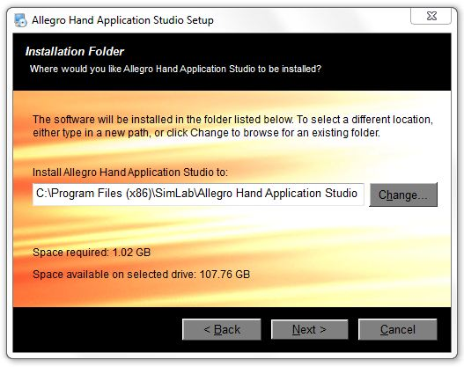

Next, select whether you want shortcuts installed for just you or every user of the computer. Shortcuts will be placed on the desktop and in the Start Menu.

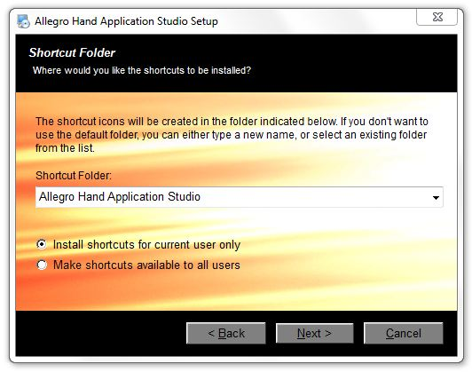

The next screen allows you to customize your installation. It is recommended that you install all components unless already installed. The third party software included with AHAS includes a *Visual C++* (*VC++*) redistributable package and the *Sentinel* USB dongle driver. If you have *RoboticsLab* installed, both the VC++ package and the USB dongle driver are likely to have already been installed. If you do not uncheck these options on this configuration screen, you will be given the opportunity on the following two screens of the AHAS installer.

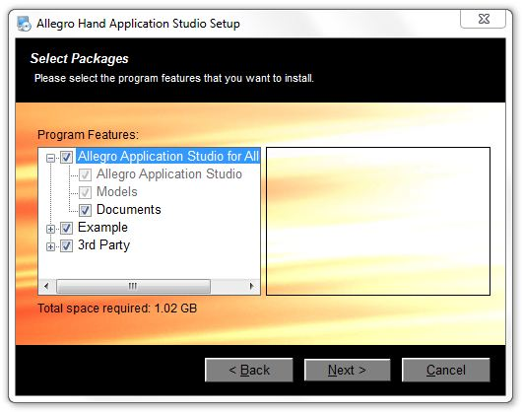

If you are unsure whether or not you have the USB dongle driver installed, please leave this option checked as it is required to run AHAS.

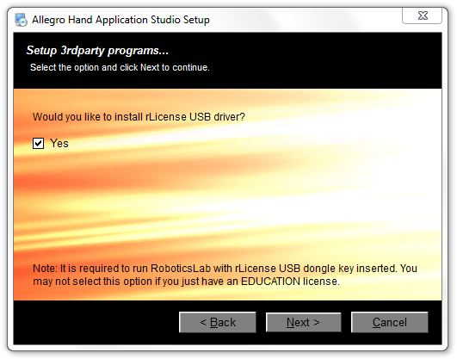

If you are unsure whether or not you have the VC++ redistributable package installed, please leave this option checked as it is required to run AHAS.

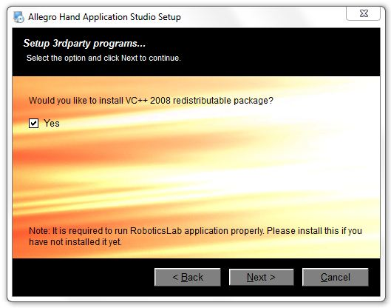

The next screen provides an overview of the software to be installed. This is your last chance to go back and change any information or quit the installer. Pressing *Next* will begin the installation.

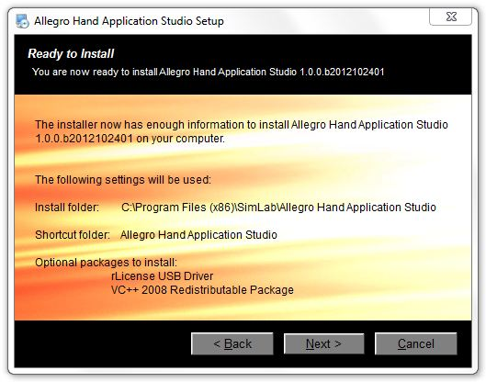

## VC++ Redistributable

After the installation of Allegro Hand Application Studio is finished, please proceed to install the *Visual C++* (*VC++*) redistributable package. The installation of this software is necessary to run AHAS.

***Note:*** *If you already have VC++ installed and are asked to repair or uninstall, choose* ***Repair****.*

## USB License Dongle Driver

After the installation of *VC++* is finished, please proceed to install the *Sentinel* USB dongle driver. The installation of this software is necessary to run AHAS.

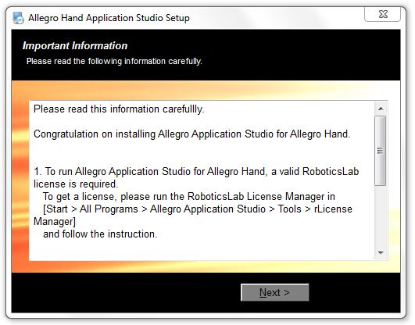

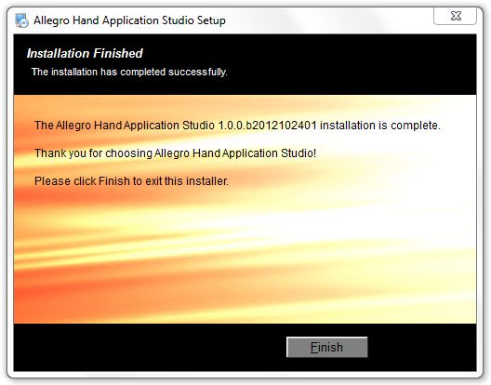

## Finishing Installation

Once installation has finished, you will be prompted to reboot your computer. Please save any unsaved work and reboot.

## AHAS License Registration

Please insert the USB license dongle included with Allegro Hand Application Studio.

Once inserted into a working USB port, navigate to the newly installed *rLicense Manager* application to install the USB device.

*Start Menu > All Programs > Allegro Hand Application Studio > Tools > rLicense Manager*

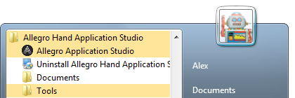

Clicking this application should install the USB device.

You should now install your CAN interface hardware and driver.

## CAN Driver Installation

Your CAN interface, either PCI (Softing, ESD, Kvaser) or USB (NI, PEAK), should be installed or plugged in to you computer before installing the proper drivers.

CAN Hardware drivers, if not included with the hardware, can be downloaded from the respective manufacturer's website. For the four CAN interfaces available through SimLab, product drivers and documentation are available at the following websites.

***Note:****After installation, check in Start Menu > Control Panel > Device Manager to make sure that a driver has installed successfully.*

### NI USB-8473s CAN

Product Page: *sine.ni.com/nips/cds/view/p/lang/en/nid/203385*

Driver Page: *joule.ni.com/nidu/cds/view/p/id/3152/lang/en*

### Softing CAN-AC2-PCI

Product Page: *http://www.softing.com/home/en/automotive-electronics/products/can-bus/interface- cards/can/pci-2.php*

Driver Page: *http://industrial.softing.com/en/products/functionality/interface-cards-gateways/pci- interface-cards/can/can-dual-channel-pci-interface-card.html*

Click "Downloads"

### Kvaser PCIcan 4xHS

Product Page: *http://www.kvaser.com/index.php?option=com_php&Itemid=261&eaninput=*

*7330130000841&lang=en&product=Kvaser%20PCIcan%204xHS*

Driver Page: *http://www.kvaser.com/index.php?option=com_php&Itemid=261&eaninput=*

*7330130000841&lang=en&product=Kvaser%20PCIcan%204xHS*

Click "Downloads"

### ESD CAN-PCI/266

Product Page: *http://www.esd-electronics-usa.com/CAN-CANopen-J1939-66-MHZ-PC-Board-PCI- 2.2-1-OR-2-CAN-Interface-CAN-PCI/266.html*

Driver Page: *http://esd.eu/en/products/can-pci266*

### PEAK PCAN-USB (Drivers available for Windows and Linux)

Product Page: *http://www.peak-system.com/PCAN-USB.199.0.html?&L=1*

Driver Page: *http://www.peak-system.com/forum/viewtopic.php?f=119&t=66*

***Note:*** *You may be required to reboot after your CAN driver installation.*

*Any of the CAN interface devices mentioned about can be purchased through SimLab.*

# Using Allegro Hand Application Studio (AHAS)

If you have not yet installed Allegro Hand Application Studio (AHAS) or your CAN interface and driver, please see the Installing Allegro Hand Application Studio section before reading this one.

## Running AHAS

When installing Allegro Hand Application Studio (AHAS), you were prompted to select an installation path where all files associated with AHAS would be stored. This installation path will be referred to as *[installPath]* from here on out.

Within the installation directory (at the top level), you will find a file titled *Allegro.exe*. Also, a shortcut to this executable should have been placed on your desktop during installation. Double-click *Allegro.exe* to launch AHAS for the Allegro Hand.

AllegroIcon.jpg

## Which Hand?

When you first run Allegro Hand Application Studio (AHAS), you are prompted to select the hand (right/left/actual/virtual) you would like to use.

### Virtual

If a *virtual* system is selected, a dynamic simulation is run using the Allegro Hand virtual model. This simulation includes full physics simulation including contact dynamics. The virtual system can be simulated without the actual system. This ability is useful for testing algorithms in a dynamics environment before trying them out of the actual hardware.

### Actual

An *Actual* system refers to the Allegro Hand hardware. If an actual system is selected, AHAS will load the corresponding (left/right) virtual model and open CAN communication with the actual Allegro Hand. The virtual Allegro Hand seen along with the Actual System simply mimics the joint kinematics (no physics or contact dynamics) of the actual system based on the encoder values obtained over CAN. Motion commands from AHAS are send directly to the actual system while the encoder feedback controls the AHAS virtual hand.

## Virtual Hand Simulation

First, we will select the *Virtual Left Hand* system and click *Finish* to start the simulation.

Selecting either virtual hand system at the Allegro Hand Application Studio (AHAS) hand selection prompt will load the AHAS dynamics simulation environment and a virtual hand model. The simulation begins running as soon as the AHAS simulation window is loaded.

***Note:*** *If presented with a Windows Firewall Security Alert, click "Allow access" to run AHAS.*

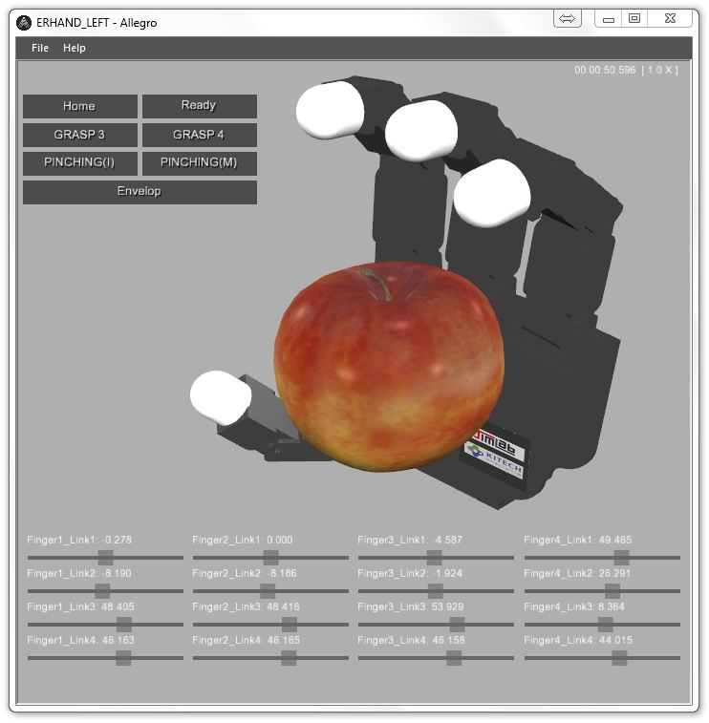

AHAS is provided along with the Allegro Hand for two main purposes. AHAS allows for ease of testing CAN communication between your PC and the Allegro Hand hardware. Secondly, AHAS provides several robust grasping algorithms for use with the Allegro Hand. The algorithms provided with AHAS can grasp a variety of object geometries for demonstration or for use at the end of a manipulator.

The grasping algorithms provided with AHAS can be explored via the graphical user interface (GUI) buttons at the top-left of the AHAS simulation window. Clicking these buttons will send a command to the virtual CAN device on the virtual Allegro Hand model.

### Home

Let's start by clicking the button entitled *Home*. The position assumed by the Allegro Hand is a starting position that ensures that all joints are oriented properly for executing a grasp.

### Ready

Click the button entitled *Ready* to prepare for each type of grasping motion.

***Note:*** *For the virtual hand, you will notice the finger joints sagging if left in ready mode too long. As the finger tip locations are controlled, all joint angles do not necessarily matter. Due to the lack of friction found in the actual system, the ready position does not remain constant. In this case, simply push Home then Ready again to prepare for a grasp.*

### Grasp 3

Click the buttons entitled *Home* then *Ready* to prepare the hand for a grasp.

Now click the button entitled *GRASP3*. This grasping algorithm is a torque-controlled, three-fingered grip. This grasp can be used for pick-and-place style object grasping as the object is held between the tips of the thumb, index and middle fingers.

### Grasp 4

Click the buttons entitled *Home* then *Ready* to prepare the hand for another type of grasp.

Click the button entitled *GRASP4*. This grasping algorithm is a torque-controlled, four-fingered grip. This grasp can be used for pick-and-place style object grasping as the object is held between the tips of the thumb and three fingers.

### Pinching (I)

Click the buttons entitled *Home* then *Ready* to prepare the hand for another type of grasp.

Click the button entitled *Pinching (I)*. This grasping algorithm is a torque-controlled, two-fingered pinch. This grasp can be used for pick-and-place style object grasping and more dexterous manipulation as the object is held between the tips of the thumb and the index finger.

### Pinching (M)

Click the buttons entitled *Home* then *Ready* to prepare the hand for another type of grasp.

Click the button entitled *Pinching (M)*. This grasping algorithm is a torque-controlled, two-fingered pinch. This grasp can be used for pick-and-place style object grasping and more dexterous manipulation as the object is held between the tips of the thumb and the middle finger.

### Envelop

Click the buttons entitled *Home* then *Ready* to prepare the hand for another type of grasp.

Click the button entitled *Envelop*. This grasping algorithm can be used to fully envelop an object within the hand's four fingers. This algorithm can handle a variety of object geometries.

### Test Encoders (actual hand only)

This button is only used when zeroing the hand joints. Pressing this button will print out the current raw encoder data. (Only available in actual hand AHAS)

### Test Motors (actual hand only)

This button is only when checking the positive direction of each motor. Pressing this button multiple times will send a positive torque value to each motor in succession. (Only available in actual hand AHAS)

### Sliders

The sliders at the bottom of the AHAS simulation window provide a secondary form of visual feedback for the sixteen joints of the hand. Each column represents a finger with *link 1* being the yaw joint attached to the palm and *link 4* being the last joint at the end of each finger.

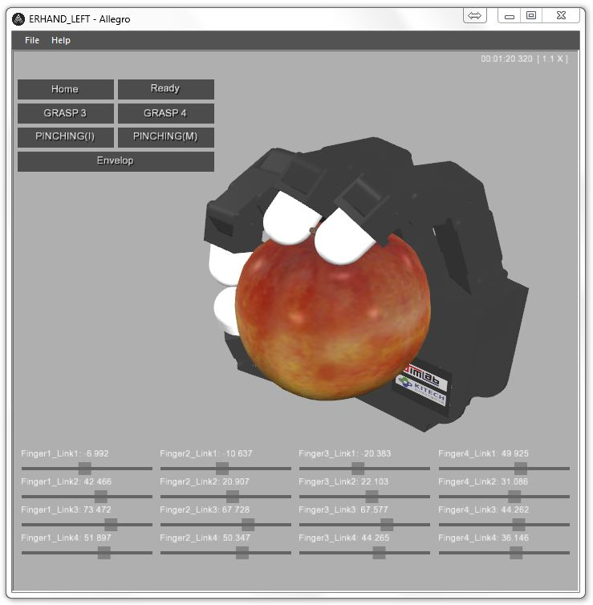

## Actual Hand

### Wiring

**v1.0**

On the back of the Allegro Hand, you will see two connectors labeled*J1*and*J5*. While these ports are identical in that they both offer CAN and power connections,*J5*offers a switch making it favorable for power. *CAN_H*and*CAN_L*get plugged into ports*1*and*2*, respectively and power*VCC*and*GND*get plugged into ports 3 and 4, respectively, on port J5.

**v2.0**

On the Allegro Hand v2.0, there is only one connector available to be used for both CAN and power. CAN_L and CAN_H get plugged into ports 3 and 4, respectively, and Power GND and VCC get plugged into ports 1 and 2, respectively, on this connector.

On the connector provided with the Allegro Hand, the wires are color coded such that power ground and voltage are a standard black and red, respectively, and CAN-Low and CAN-High are green and yellow, respectively.

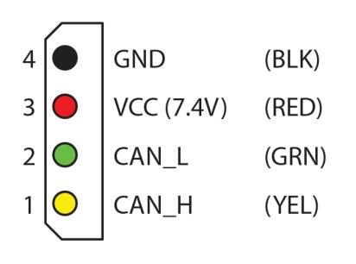

### Power

The Allegro Hand must be powered by 7.4VDC (7.0 - 8.1 VDC) and at least 5 Amps. If a minimum of 5A is not provided, the motors will brown-out during grasping.

Once the power supply is on at the rated values, the power switch on the back of the Allegro Hand can be switched on (upward towards the fingers) to provide power to the hand.

## AHAS

With the hand powered on and the CAN connected, it is finally time to run Allegro Hand Application Studio.

A virtual Allegro Hand, left or right, can be loaded by clicking *New* in the *File* drop-down menu (*File > New*) or by quitting and reopening Allegro Hand Application Studio.

Again, you will presented with the AHAS hand selection window. This time we will select the *Actual Left Hand System* (or a right hand if that's what you have) and click *Next* to select the type of CAN interface you are using. Click *Finish* to start AHAS.

***Note:*** *If you have a right hand, proceed accordingly.*

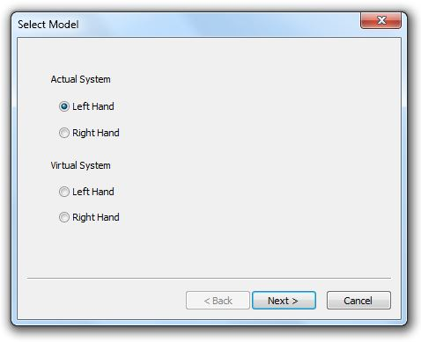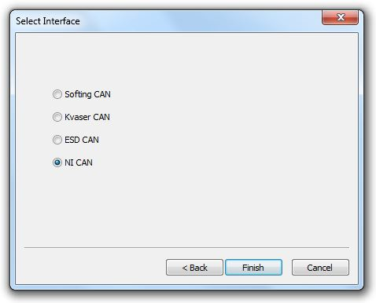

While the CAN communication is established at start-up, the motors must be turned on using the *On* button before commands can be sent and encoder values received.

***Note:****You should always straighten out all of the fingers before running Allegro Hand Application Studio or any other hand control application (think High-Five). This habit poses the fingers as far away as possible from any collision that could occur in the event of unexpected motion. This pose also increases the reliability of the encoders in finding the hand's initial position.*

Once the *On* button is pressed, the AHAS hand model is updated to reflect the actual Allegro Hand. Move the fingers around a bit manually to make sure the communication is, in fact, established.

For the actual hand, the same grasping algorithms can be executed via the GUI interface. You can use the hand to manipulate reasonably sized objects of many shapes. The virtual hand will continue to reflect any motion the actual hand makes.

## Quitting

You can quit Allegro Hand Application Studio in two ways. First, you can quit by clicking *Exit* in the *File* drop-down menu (*File > Exit*). You can also quit by click the *X* button to the right of the AHAS window's title bar.

# Joint Dimensions

All dimensions are displayed in millimeters (mm) and degrees.





# Joint Directions

## Right Hand



## Left Hand



# Mounting the Allegro Hand

All dimensions are displayed in millimeters (mm) and degrees.

## Mounting Block Removal

The mounting block is connected to the Allegro Hand using twelve (12) M2 socket-head cap screws (6 on each side).



Remove six (6) screws on either side of the hand.

**DO** **NOT** remove the two (2) screws labeled A or the corresponding screws on the other side of the hand.   
  
***Note:****Secure the hand while unscrewing the mounting block to avoid dropping the hand once disconnected.*



Once the twelve (12) screws have been removed, the mounting block can be removed from the bottom of the hand.



## Mounting

The block can be mounted to a surface using two (2) M3 socket-head cap screws.  
  
***Note:****The hand should be mounted to a raised area so as to avoid thumb-mount interference during hand movement.*



## Reassembly

Place the hand onto the mounting block and replace the twelve (12) M2 socket-head cap screws

(6 on each side).



## Mount Block Dimensions

The relevant dimensions of the mounting block are presented in millimeters (mm).



# CAN Protocol

## Baud-Rate

The CAN communication baud-rate is 1Mbps.

## 

## Non-Periodic Communication

Messages can be sent to initialize or stop CAN communication.

## 

## Periodic Communication

The Allegro Hand control software attempts to communicate with the real or simulated hand at a regular control interval. Every 3 milliseconds, the joint torques are calculated and the joint angles are updated.

# CAN Frames

## Standard CAN Packet

The standard CAN packet used for communication contains 8 bytes.

Code : CAN Packet Structure

|  |
| --- |
| typedef struct{  unsigned char STD_EXT;  unsigned long msg_id; //message identifier  unsigned char data_length; //  char data[8]; // data array  } can_msg; |

## 

## ID (Message Identifier)

The 4 byte integer CAN message is split into the command ID (26 bits), destination ID (3bits) and source ID (3 bits).

Table : CAN Message Identifiers

|  |  |  |  |  |  |  |  |  |
| --- | --- | --- | --- | --- | --- | --- | --- | --- |
| 1 | 8 | 16 | 24 | 26 | 27 | 29 | 30 | 32 |
| Command ID | | | | | DSTN. ID | | Source ID | |

## Command Identifiers

Table : CAN Message Command Identifiers

|  |  |  |  |  |
| --- | --- | --- | --- | --- |
| **Variable name** | **Value** | **Description** | **Source** | **Destination** |
| ID_CMD_SET_SYSTEM_ON | 0x01 | Start periodic communication | ID_DEVICE_MAIN | ID_COMMON |
| ID_CMD_SET_SYSTEM_OFF | 0x02 | Stop periodic communication | ID_DEVICE_MAIN | ID_COMMON |
| ID_CMD_SET_PERIOD | 0x03 | Set communication frequency | ID_DEVICE_MAIN | ID_COMMON |
| ID_CMD_SET_MODE_JOINT | 0x04 | Command Transmission Mode | ID_DEVICE_MAIN | ID_COMMON |
| ID_CMD_SET_MODE_TASK | 0x05 | Command Transmission Mode | ID_DEVICE_MAIN | ID_COMMON |
| ID_CMD_SET_TORQUE_1 | 0x06 | Index finger (1) torque command | ID_DEVICE_MAIN | ID_COMMON |
| ID_CMD_SET_TORQUE_2 | 0x07 | Middle finger (2) toque command | ID_DEVICE_MAIN | ID_COMMON |
| ID_CMD_SET_TORQUE_3 | 0x08 | Pinky finger (3) torque command | ID_DEVICE_MAIN | ID_COMMON |
| ID_CMD_SET_TORQUE_4 | 0x09 | Thumb torque command | ID_DEVICE_MAIN | ID_COMMON |
| ID_CMD_SET_POSITION_1 | 0x0a | *(unused)* |  |  |
| ID_CMD_SET_POSITION_2 | 0x0b | *(unused)* |  |  |
| ID_CMD_SET_POSITION_3 | 0x0c | *(unused)* |  |  |
| ID_CMD_SET_POSITION_4 | 0x0d | *(unused)* |  |  |
| ID_CMD_QUERY_STATE_DATA | 0x0e | Request joint state | ID_DEVICE_MAIN | ID_COMMON |
| ID_CMD_QUERY_STATE_DATA | 0x0e | Joint state response | ID_DEVICE_SUB_01  ID_DEVICE_SUB_02  ID_DEVICE_SUB_03  ID_DEVICE_SUB_04 | ID_DEVICE_MAIN |
| ID_CMD_QUERY_CONTROL_DATA | 0x0f | Joint state response | ID_DEVICE_SUB_01  ID_DEVICE_SUB_02  ID_DEVICE_SUB_03  ID_DEVICE_SUB_04 | ID_DEVICE_MAIN |

## Source and Destination Identifiers

Table : Source and Destination Identifiers

|  |  |  |
| --- | --- | --- |
| **Variable name** | **Value** | **Description** |
| ID_COMMON | 0x01 | Allegro Hand |
| ID_DEVICE_MAIN | 0x02 | Control PC |
| ID_DEVICE_SUB_01 | 0x03 | Index Finger |
| ID_DEVICE_SUB_02 | 0x04 | Middle Finger |
| ID_DEVICE_SUB_03 | 0x05 | Little Finger |
| ID_DEVICE_SUB_04 | 0x06 | Thumb |

# Case-study: Softing CAN

In this chapter, sample code demonstrating the implementation of the CAN communication interface is provide. This is the foundation for Softing PCI CAN.

## Opening the CAN Communication Channel

Code : Opening the CAN Communication Channel

|  |
| --- |
| char ch_name[256];  sprintf_s(ch_name, 256, "CAN-ACx-PCI_%d", ch);  INIL2_initialize_channel(&hCAN[ch-1], ch_name);  L2CONFIG L2Config;  L2Config.fBaudrate = 1000.0;  L2Config.bEnableAck = 0;  L2Config.bEnableErrorframe = 0;  L2Config.s32AccCodeStd = 0;  L2Config.s32AccMaskStd = 0;  L2Config.s32AccCodeXtd = 0;  L2Config.s32AccMaskXtd = 0;  L2Config.s32OutputCtrl = GET_FROM_SCIM;  L2Config.s32Prescaler = 1;  L2Config.s32Sam = 0;  L2Config.s32Sjw = 1;  L2Config.s32Tseg1 = 4;  L2Config.s32Tseg2 = 3;  L2Config.hEvent = (void*)-1;  CANL2_initialize_fifo_mode(hCAN[ch-1], &L2Config); |

## CAN Initialization

Code : Opening the CAN Communication Channel

|  |
| --- |
| long Txid;  unsigned char data[8];  Txid = ((unsigned long)ID_CMD_SET_PERIOD<<6) | ((unsigned long)ID_COMMON <<3) | ((unsigned long)ID_DEVICE_MAIN);  data[0] = (unsigned char)period_msec;  canWrite(hCAN, Txid, data, 1, STD);  Sleep(10);  Txid = ((unsigned long)ID_CMD_SET_MODE_TASK<<6) | ((unsigned long)ID_COMMON <<3) | ((unsigned long)ID_DEVICE_MAIN);  canWrite(hCAN, Txid, data, 0, STD);  Sleep(10);  Txid = ((unsigned long)ID_CMD_QUERY_STATE_DATA<<6) | ((unsigned long)ID_COMMON <<3) | ((unsigned long)ID_DEVICE_MAIN);  canWrite(hCAN, Txid, data, 0, STD); |

## Starting Periodic CAN Communication

When you start periodic CAN communication, joint angles are automatically updated according to the torque control input.

Code : Starting Periodic CAN Communication

|  |
| --- |
| long Txid;  unsigned char data[8];  Txid = ((unsigned long)ID_CMD_QUERY_STATE_DATA<<6) | ((unsigned long)ID_COMMON <<3) | ((unsigned long)ID_DEVICE_MAIN);  canWrite(hCAN[ch-1], Txid, data, 0, STD);  Sleep(10);  Txid = ((unsigned long)ID_CMD_SET_SYSTEM_ON<<6) | ((unsigned long)ID_COMMON <<3) | ((unsigned long)ID_DEVICE_MAIN);  canWrite(hCAN[ch-1], Txid, data, 0, STD); |

## Stopping Periodic CAN Communication

Code : Stopping Periodic CAN Communication

|  |
| --- |
| long Txid;  unsigned char data[8];  Txid = ((unsigned long)ID_CMD_SET_SYSTEM_OFF<<6) | ((unsigned long)ID_COMMON <<3) | ((unsigned long)ID_DEVICE_MAIN);  canWrite(hCAN[ch-1], Txid, data, 0, STD); |

## Transmitting Control Torques

Control inputs for the four joints in each finger should be packed in a single CAN frame. The sample code below demonstrates how to encode four PWM inputs into an 8 byte data buffer and how to set the CAN frame ID properly.

Code : Transmitting Control Torques

|  |
| --- |
| long Txid;  unsigned char data[8];  float torque2pwm = 800.0f  short pwm[4] = {  0.1*torque2pwm,  0.1*torque2pwm,  0.1*torque2pwm,  0.1*torque2pwm  };  if (findex >= 0 && findex < 4)  {  data[0] = (unsigned char)( (pwm[0] >> 8) & 0x00ff);  data[1] = (unsigned char)(pwm[0] & 0x00ff);  data[2] = (unsigned char)( (pwm[1] >> 8) & 0x00ff);  data[3] = (unsigned char)(pwm[1] & 0x00ff);  data[4] = (unsigned char)( (pwm[2] >> 8) & 0x00ff);  data[5] = (unsigned char)(pwm[2] & 0x00ff);  data[6] = (unsigned char)( (pwm[3] >> 8) & 0x00ff);  data[7] = (unsigned char)(pwm[3] & 0x00ff);  Txid = ((unsigned long)(ID_CMD_SET_TORQUE_1 + findex)<<6) | ((unsigned long)ID_COMMON <<3) | ((unsigned long)ID_DEVICE_MAIN);  canWrite(hCAN, Txid, data, 8, STD);  } |

## Receiving Joint Angles

Each finger consists of four joints. The joint angles for those four joints can be received via one CAN packet. The sample code below demonstrates the method for decoding the data buffer and reading the joint angles.

The sample code assumes that when fingers are in their zero positions, the joint angles from the CAN packet are *32768*. In practice, users should perform experiments and introduce offsets to obtain the zero position.

Code : Receiving Joint Angles

|  |
| --- |
| char cmd;  char src;  char des;  int len;  unsigned char data[8];  int ret;  can_msg msg;  PARAM_STRUCT param;  ret = CANL2_read_ac(hCAN, &param);  switch (ret)  {  case CANL2_RA_DATAFRAME:  msg.msg_id = param.Ident;  msg.STD_EXT = STD;  msg.data_length = param.DataLength;    msg.data[0] = param.RCV_data[0];  msg.data[1] = param.RCV_data[1];  msg.data[2] = param.RCV_data[2];  msg.data[3] = param.RCV_data[3];  msg.data[4] = param.RCV_data[4];  msg.data[5] = param.RCV_data[5];  msg.data[6] = param.RCV_data[6];  msg.data[7] = param.RCV_data[7];  break;  }  cmd = (char)( (msg.msg_id >> 6) & 0x1f );  des = (char)( (msg.msg_id >> 3) & 0x07 );  src = (char)( msg.msg_id & 0x07 );  len = (int)( msg.data_length );  for(int nd=0; nd<len; nd++)  data[nd] = msg.data[nd];  switch (cmd)  {  case ID_CMD_QUERY_CONTROL_DATA:  {  if (id_src >= ID_DEVICE_SUB_01 && id_src <= ID_DEVICE_SUB_04)  {  int temp_pos[4]; // raw angle data  float ang[4]; // degree  float q[4]; // radian  temp_pos[0] = (int)(data[0] | (data[1] << 8));  temp_pos[1] = (int)(data[2] | (data[3] << 8));  temp_pos[2] = (int)(data[4] | (data[5] << 8));  temp_pos[3] = (int)(data[6] | (data[7] << 8));  ang[0] = ((float)(temp_pos[0]-32768)*(333.3f/65536.0f))*(1);  ang[1] = ((float)(temp_pos[1]-32768)*(333.3f/65536.0f))*(1);  ang[2] = ((float)(temp_pos[2]-32768)*(333.3f/65536.0f))*(1);  ang[3] = ((float)(temp_pos[3]-32768)*(333.3f/65536.0f))*(1);  q[0] = (3.141592f/180.0f) * ang[0];  q[1] = (3.141592f/180.0f) * ang[1];  q[2] = (3.141592f/180.0f) * ang[2];  q[3] = (3.141592f/180.0f) * ang[3];  }  }  } |

# Technical Support

The newest versions of all documents found in this manual can be found in the Allegro Hand wiki at

**simlab.co.kr/AllegroHand/wiki**

A forum is also available on the wiki where users can share problems and solutions with each other and with SimLab. Upon request, you may be granted editing access to the wiki to host your tutorials and samples of your work. In fact, we would love to collaborate.

For any further questions please contact us.

|  |  |
| --- | --- |
| **Address** | Hyobong8 Bldg 2Fl, 1425-9 Seocho-dong Seocho-gu, Seoul 137-864, Korea (13, Nambusunhwan-ro 333-gil) |
| **Phone** | +82-2-3471-2014 |
| **Fax** | +82-2-6280-9931 |
| **Email** | alexalspach@simlab.co.kr |

**Please enjoy your Allegro Hand,**

and feel free to share your success stories and videos!

The Allegro Hand Wiki and User's Manual is written and maintained by Alex Alspach

alexalspach@gmail.com